CHAPTER 1

INTRODUCTION

Consumer behaviour in e-commerce is a vital area of study that impacts business strategies and outcomes. As online shopping grows, understanding the factors influencing consumer purchasing decisions is essential. Key elements such as convenience, product variety, and pricing significantly shape consumer preferences. The ability to shop anytime and anywhere has transformed consumer expectations, making convenience a primary driver for e-commerce. Additionally, the extensive range of products available online allows consumers to make informed choices through easy comparisons, while competitive pricing strategies attract potential buyers. Analyzing these dynamics enables businesses to refine their offerings and enhance customer satisfaction.

User experience and trust are also crucial in influencing consumer behaviour in e-commerce. A well-designed platform with seamless navigation and fast loading times can greatly enhance the shopping experience, leading to higher conversion rates. Moreover, as concerns about security and data privacy rise, consumers are more likely to engage with platforms that prioritize these aspects. Mobile shopping continues to increase in popularity, necessitating that businesses optimize their websites for mobile devices. Personalization through data analytics further improves customer engagement by tailoring recommendations and marketing efforts to individual preferences.

Insights from studying consumer behaviour provide actionable recommendations for e-commerce businesses. By identifying peak purchasing times, popular product types, and preferred payment methods, companies can optimize inventory management and marketing strategies effectively. Understanding which products are bestsellers aids in making informed decisions about stock levels and promotional campaigns. Employing statistical analysis techniques can reveal significant differences in spending patterns based on various factors. Ultimately, a data-driven approach allows businesses to adapt to changing market dynamics and enhance overall customer satisfaction, ensuring sustained growth in the competitive e-commerce landscape.
CHAPTER 2

IMPLEMENTATION

2.1. Module Explanation

2.1.1 Objective:

To analyze consumer behaviour in e-commerce by studying factors such as gender, item categories, purchase amounts, and review ratings. It aims to uncover trends in purchasing habits and frequency across different demographics and locations. The analysis will explore the influence of shipping types and payment methods on consumer preferences and satisfaction. Additionally, it seeks to identify correlations between purchase amounts and review ratings to gauge customer satisfaction levels. By segmenting customers based on behaviour, the study will provide actionable insights to improve targeting and personalization. The ultimate goal is to enhance e-commerce strategies and optimize customer engagement.

2.1.2 Components:
- Data Collection:
  - Description: Data cleaning ensures the dataset is accurate, consistent, and free of errors or missing values. It prepares raw data for effective analysis and minimizes the risk of unreliable insights.
  - Usage: Provides a clean foundation for analysis by removing inaccuracies and
noise.
- Descriptive Analysis:
  - Description: Descriptive analysis summarizes key statistics such as averages, counts, and distributions in the dataset. It helps in understanding overall patterns and characteristics of customer behaviour
  - Usage: Gives a foundational overview of the data for deeper exploration.

- Customer Demographics Analysis :
  - Description: This analysis identifies patterns in customer attributes like gender, location, and age. It highlights demographic preferences and their influence on purchasing decisions
  - Usage: Assists in segmenting customers and tailoring marketing strategies.

- Statistical Analysis:
  - Description: Analyzes review ratings and their relationship to factors like shipping and payment methods. It evaluates how satisfied customers are with their purchases.
  - Usage: Identifies areas to improve customer satisfaction and loyalty.

- Visualization Tools:
  - Description: Transforms data insights into visual representations like graphs and charts. This makes it easier to interpret and communicate complex findings.
  - Usage: Enhances understanding and simplifies decision-making for stakeholders.
- Actionable Insights:
  - Description: Converts analysis findings into practical recommendations for business improvement. These insights are grounded in data and trends observed.
  - Usage: Guides decision-makers in enhancing e-commerce strategies and
performance.

2.1.3 Workflow :

- Data Collection and Loading: Importing the dataset into a structured format using
tools like Pandas, ensuring compatibility with analysis workflows.

- Data Cleaning: Addressing inconsistencies, such as missing or duplicate data, ensuring
dataset integrity and reliability.

- Exploratory Data Analysis: Analysing trends in purchase volume, popular product categories, payment methods, and frequency of purchases using visual and statistical tools.
- Visualization: Generating visual summaries like bar charts, pie charts, histogram and
heatmaps to highlight key insights, making patterns easily interpretable.

- Advanced Analytics: Incorporating statistical and predictive techniques to understand customer preferences, such as purchase behaviour, popular product categories and payment methods.

- Reporting: Summarizing findings with actionable recommendations for stakeholders,
presented in an easily digestible format for strategic decision-making.

2.1.4 Benefits :
- Understanding Customer Preferences :
Analyzing the dataset helps identify customer preferences for product categories,
payment methods, and shipping types. This insight enables businesses to tailor their
offerings to better meet customer needs, leading to improved sales and customer
satisfaction.

- Personalized Marketing :
By segmenting customers based on behaviours such as purchase frequency and
demographics, businesses can create targeted marketing campaigns. Personalization
enhances customer engagement and drives higher conversion rates.

- Optimizing Operations :
Insights into purchase frequency and customer location allow businesses to optimize
inventory management and logistics. This reduces operational costs, streamlines
delivery processes, and improves overall efficiency.

2.2 Explanation of each module code
2.2.1 Cleaning and Preprocessing
Data cleaning and preparation are essential steps to ensure the dataset is accurate and ready for
analysis. The following processes were undertaken:

- Handling Missing Data:

  - Identify Missing Values: Check for missing entries in critical columns like item purchased, payment method, purchase amount.

  - Imputation:
- Use mean/median/mode for numerical data.
- Replace missing categorical values with the most frequent category or "Unknown."
- Deletion: Remove rows or columns with excessive missing data if imputation is not feasible.

- Handling Outliers:

  - Use statistical methods (e.g., Z-scores, IQR) to detect outliers in numerical fields like price, sales quantity, or revenue.

  - Validate whether outliers are valid (e.g., purchase amount) or need correction/removal.

- Removing Duplicates Records:

  - Identified and removed duplicate entries to prevent skewed results. This was done by checking for identical rows across all columns.

- Dealing with Inconsistent Data:

  - Product Categories: Correct spelling errors or merge similar categories.

  - Customer Data: Standardize locations, names, and other fields to remove inconsistencies.

- Data Normalization/Scaling :

  - Normalization was performed by removing outliers using the Z-score method, filtering values beyond 3 standard deviations from the mean to enhance data quality for analysis.

Pre-processing ensures the dataset is clean, reliable, and primed for meaningful analysis or model training.

2.2.2 Visual Representation, Exploratory Data Analysis (EDA) and Statistical Inference
We conducted various visualizations and statistical analyses to explore data distributions and relationships between key variables. This included Exploratory Data Analysis (EDA) for visual insights and Statistical Inference using Confidence Intervals (CI) and Hypothesis Testing. Visual representation plays a crucial role in analyzing consumer behavior and sales data, as it allows for the effective communication of insights through graphical formats.

Exploratory Data Analysis (EDA)
EDA was performed to understand data distributions, identify the patterns and explore relationships between the variables. In this analysis, we utilize five key visualizations:
- Pie Chart: This chart is employed to identify the distribution of sales revenue by product category, displaying the proportion of total sales attributed to each category. It provides a clear visual indication of which product categories contribute most to total sales.
- Histogram: Used to analyze the distribution of purchase amounts, histograms illustrate the frequency of purchase amounts across different ranges. This helps in observing spending patterns and identifying any trends in customer behavior.
- Box Plot: This visualization is utilized to depict the distribution of purchase amounts across different age groups. Box plots show the median, quartiles, and potential outliers, allowing us to identify variations in spending across customer demographics.
- Bar Graph: A bar chart is used to show the average review ratings by product category. This allows for easy comparison of how different product categories are rated by customers, highlighting potential areas for improvement or customer satisfaction.
- Line Chart: This chart is used to visualize the relationship between purchase frequency and average purchase amount. It shows how customers with different frequencies of purchase behave in terms of the amount spent, providing valuable insights into consumer spending habits.

Statistical Inference
Following Exploratory Data Analysis (EDA), statistical inference was used to provide quantitative insights. This involved Confidence Intervals (CI) and Hypothesis Testing as follows:
- Confidence Intervals (CI):
Confidence intervals were calculated for the purchase amount to estimate the range within which the true mean of purchase amounts is likely to fall. A 95% confidence interval was used, providing an uncertainty measure around the sample mean to understand the variations in customer spending.
- Hypothesis Testing:
  - Pearson Correlation: A Pearson’s correlation was conducted to assess the relationship between Age and Purchase Amount (USD).
  - Hypothesis:
    - Null Hypothesis (H₀): There is no significant relationship between age and purchase amount.
    - Alternative Hypothesis (Hₐ): There is a significant relationship between age and purchase amount.
  - The p-value from the test was compared to a significance level of 0.05. A p-value below 0.05 would lead to rejecting the null hypothesis, indicating a significant relationship between Age and Purchase Amount (USD).

CHAPTER 3

RESULTS AND DISCUSSION

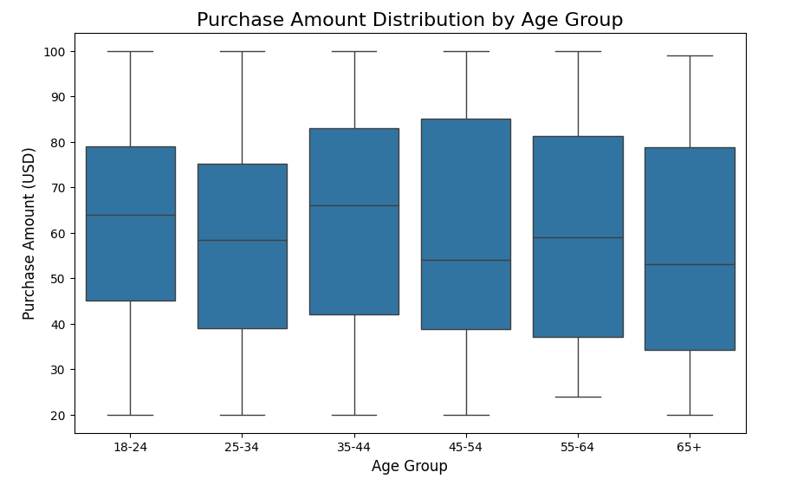
This chapter presents the results and visualizations through detailed graphs.
Fig .3.1. Box Plot for Purchase Amount Distribution by Age Group

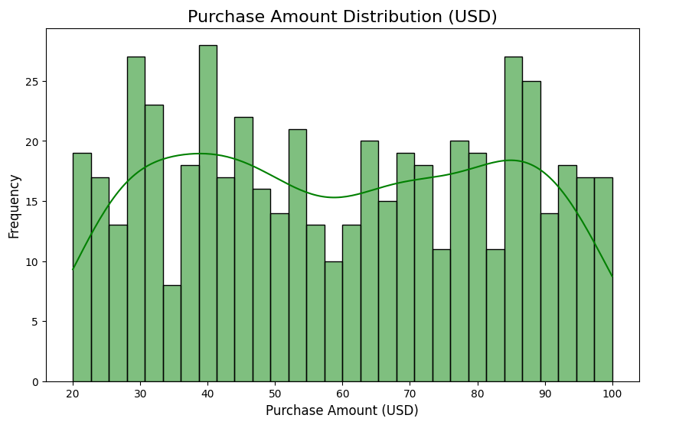
Fig. 3.1 shows the box plot of Purchase Amount Distribution by Age Group, which visualizes how the purchase amounts vary across different age groups (18-24, 25-34, 35-44, 45-54, 55-64, 65+).

Fig.3.2. Histogram

Fig. 3.2 shows the histogram of Purchase Amount Distribution (USD), displaying the frequency of different purchase amounts.
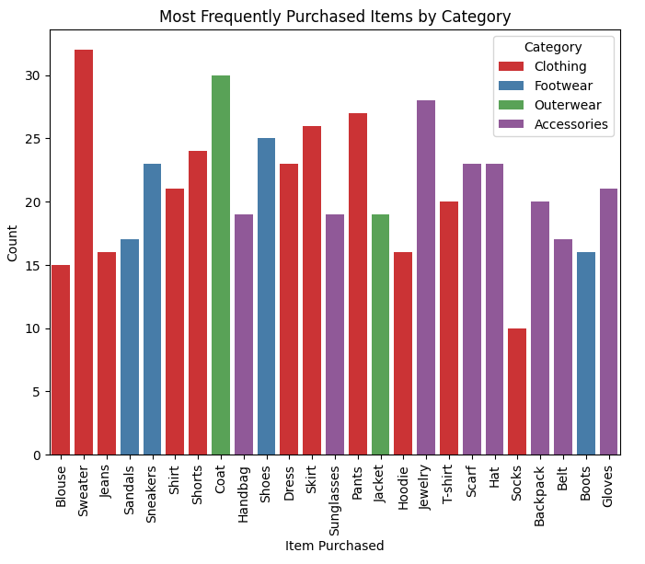

Fig.3.3. Bar chart for Most frequently purchased items by category

Fig. 3.3 shows the bar chart of Most Frequently Purchased Items by Category, illustrating the count of items purchased across different product categories.
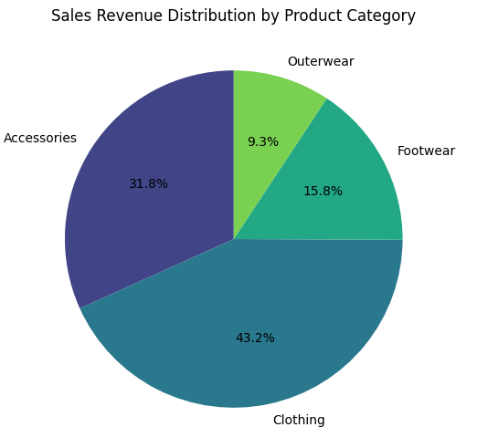

Fig.3.4. Pie chart for Sales Revenue Distribution by Product Category
Fig. 3.4 represents the bar chart of Sales, Revenue, and Distribution by Product Category, illustrating how product categories contribute to overall sales and revenue. It provides insights into category performance.
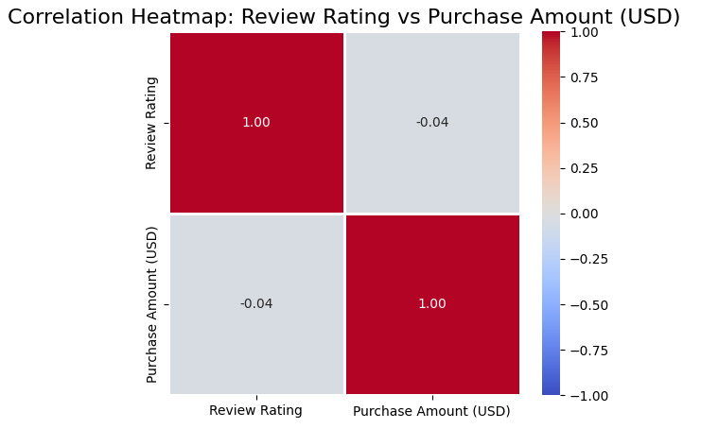

Fig.3.5. Correlation Heatmap

Fig. 3.5 displays the correlation heatmap between review rating and purchase amount, highlighting the relationship between ratings and spending. The colour intensity indicates the strength of the correlation, helping to reveal trends in consumer behaviour.
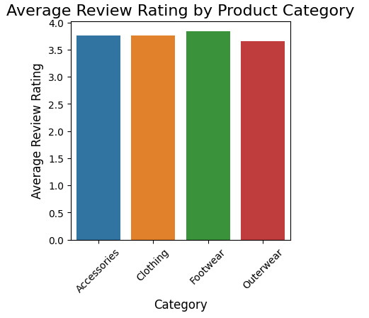

Fig.3.6. Bar chart for Average Review Rating by Product Category

Fig. 3.6 presents the bar chart for Average Review Rating by Product Category, illustrating how customer ratings vary across different product categories. Each bar represents the average rating for a specific category, providing a clear comparison of customer satisfaction levels across products. This chart helps identify which categories receive higher or lower ratings, offering insights into product performance and consumer preferences.
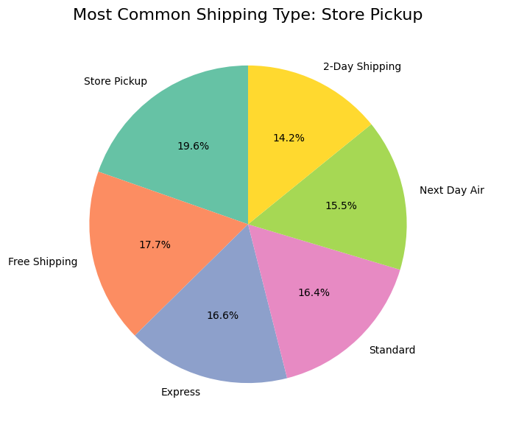

Fig.3.7. Most Common Shipping Type

Fig. 3.7 shows a pie chart for the most common shipping type, displaying the distribution of different shipping methods used by customers. Each slice represents a shipping type, with the size of the slice indicating its relative frequency.
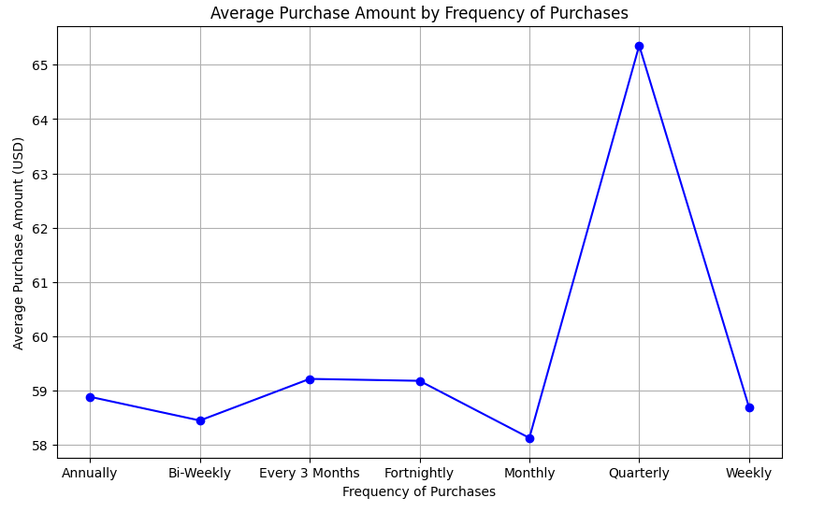

Fig.3.8. Line Graph

Fig 3.8 shows the Line chart for Average Purchase Amount by Frequency of Purchases. The graph illustrates how the average purchase amount changes as the frequency of purchases increases, revealing potential patterns in consumer spending behaviour.
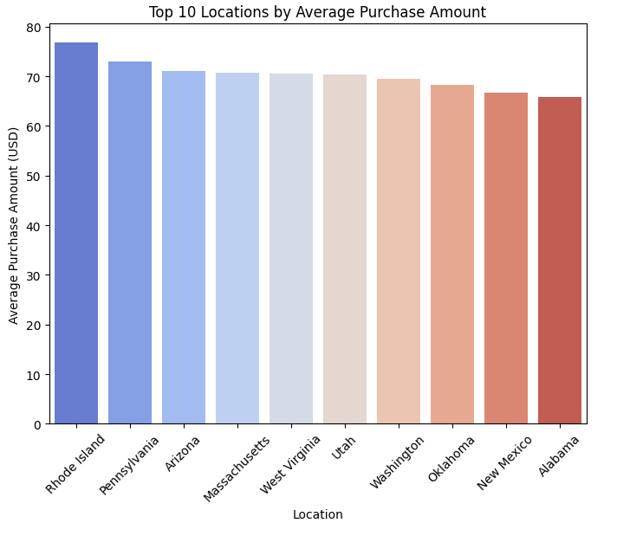

Fig.3.9. Bar chart for Top 10 Locations by Average Purchase Amount

Fig. 3.9 shows the bar graph highlighting locations ranked by their average purchase amount. Each bar represents a region, with its height reflecting the average spending per purchase. This allows for easy comparison of consumer spending across different areas, helping to identify regions with higher or lower average transaction values.
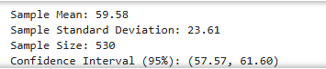

Fig.4.0. Confidence Interval

Fig.4.0 represents a confidence interval (CI) for the mean value, which is a statistical range used
to estimate where the true population mean is likely to lie, based on a sample.

Fig.4.1. Hypothesis Testing

Fig. 4.1 illustrates the Pearson correlation test between Age and Purchase Amount, assessing whether there is a statistically significant relationship between these two variables. The correlation coefficient and p-value are calculated, with the null hypothesis being rejected if the p-value is less than 0.05, indicating a significant relationship.
CHAPTER 4

CONCLUSION

In conclusion, the analysis of the dataset, which includes factors such as customer demographics, item categories, purchase amounts, and review ratings, provides valuable insights into consumer behaviour in e-commerce. By examining these variables, businesses can identify key patterns in purchasing habits, payment methods, and shipping preferences. This understanding helps companies refine their product offerings and tailor their marketing strategies to better meet customer expectations.

The segmentation of customers based on attributes like gender, location, and purchase frequency allows for more targeted and effective marketing campaigns. Personalized promotions can be designed to engage specific customer groups, leading to higher conversion rates and improved customer loyalty. By understanding the different needs and preferences of various customer segments, businesses can optimize their approach to maximize customer satisfaction and retention.

Review ratings, shipping types, and payment methods also play a crucial role in shaping consumer satisfaction. Analyzing the relationship between these factors and the purchase amount helps businesses gauge customer experiences and identify areas for improvement. Addressing issues in delivery, payment, or product quality can significantly enhance the overall customer experience and foster stronger customer relationships.

Finally, operational insights from the dataset, such as purchasing frequency and location, enable businesses to streamline logistics and inventory management. By optimizing shipping methods and stock levels based on customer behaviour, companies can reduce costs and improve service efficiency. In turn, this leads to faster delivery, better customer satisfaction, and improved overall e-commerce performance.

REFERENCES

- Python Software Foundation. (n.d.). Jupyter Notebook and JupyterLab Documentation. https://jupyter.org/
- Kaggle. (n.d.). Mobile Device Usage and User Behaviour Dataset.
https://www.kaggle.com/datasets/zeesolver/consumer-behavior-and-shopping-habits-dataset
- Python Software Foundation. (n.d.). Python Documentation. https://docs.python.org/3/
- OpenAI. (n.d.). ChatGPT for coding assistance and Python exploration. https://chatgpt.com/

